*Kyle Topasna*

*Udacity Project 2*

Classical Planning

Air Cargo Problem 1:

|  | **actions** | **compute_time** | **graph_expansions** | **nodes_explored** | **plan_length** |
| --- | --- | --- | --- | --- | --- |
| **acp_1_bfs** | 20 | 0.042688 | 43 | 178 | 6 |
| **acp_1_dfs** | 20 | 0.012300 | 21 | 84 | 20 |
| **acp_1_ucs** | 20 | 0.030821 | 60 | 240 | 6 |
| **acp_1_greedy_best_first_search h_unmet_goals** | 20 | 0.003025 | 7 | 29 | 6 |
| **acp_1_greedy_best_first_search h_levelsum** | 20 | 0.826779 | 6 | 28 | 6 |
| **acp_1_greedy_best_first_search h_maxlevel** | 20 | 0.230910 | 6 | 24 | 6 |
| **acp_1_greedy_best_first_search h_setlevel** | 20 | 1.028256 | 6 | 28 | 6 |
| **acp_1_astar_search h_unmet_goals** | 20 | 0.019108 | 50 | 206 | 6 |
| **acp_1_astar_search h_levelsum** | 20 | 0.394338 | 28 | 122 | 6 |
| **acp_1_astar_search h_maxlevel** | 20 | 0.347104 | 43 | 180 | 6 |
| **acp_1_astar_search h_setlevel** | 20 | 1.048690 | 33 | 138 | 6 |

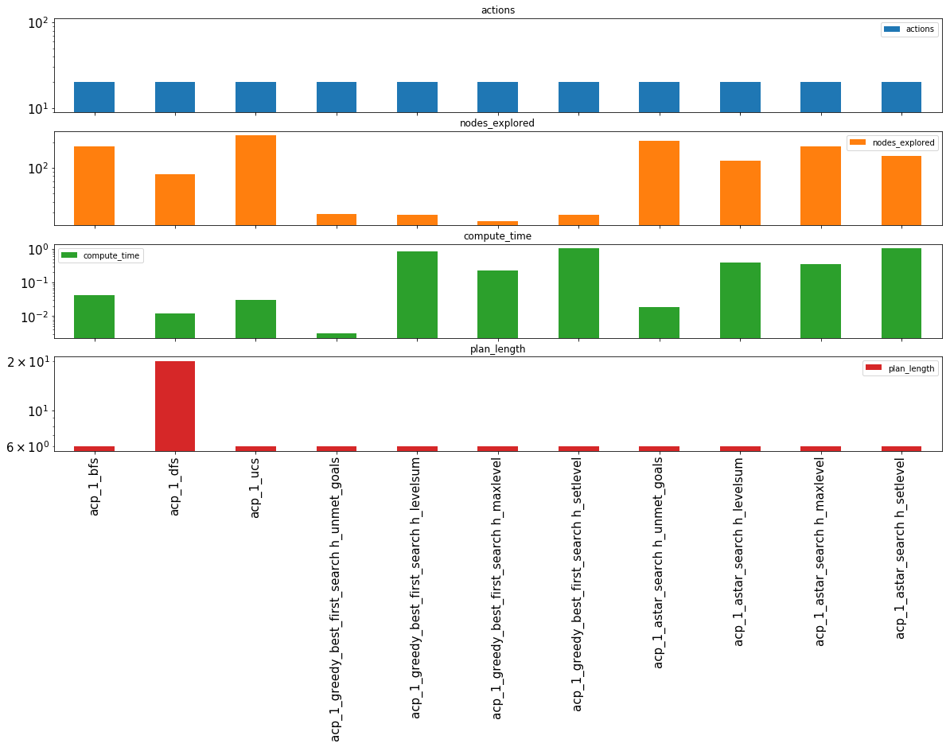

Air Cargo Problem 2:

|  | **actions** | **compute_time** | **graph_expansions** | **nodes_explored** | **plan_length** |
| --- | --- | --- | --- | --- | --- |
| **acp_2_bfs** | 72 | 0.504165 | 3343 | 30503 | 9 |
| **acp_2_dfs** | 72 | 0.713412 | 624 | 5602 | 619 |
| **acp_2_ucs** | 72 | 0.893246 | 5154 | 46618 | 9 |
| **acp_2_greedy_best_first_search h_unmet_goals** | 72 | 0.024852 | 17 | 170 | 9 |
| **acp_2_greedy_best_first_search h_levelsum** | 72 | 2.571643 | 9 | 86 | 9 |
| **acp_2_greedy_best_first_search h_maxlevel** | 72 | 2.742849 | 27 | 249 | 9 |
| **acp_2_greedy_best_first_search h_setlevel** | 72 | 5.399611 | 9 | 84 | 9 |
| **acp_2_astar_search h_unmet_goals** | 72 | 0.957883 | 2467 | 22522 | 9 |
| **acp_2_astar_search h_levelsum** | 72 | 35.475223 | 357 | 3426 | 9 |
| **acp_2_astar_search h_maxlevel** | 72 | 202.709443 | 2887 | 26594 | 9 |
| **acp_2_astar_search h_setlevel** | 72 | 322.180424 | 1037 | 9605 | 9 |

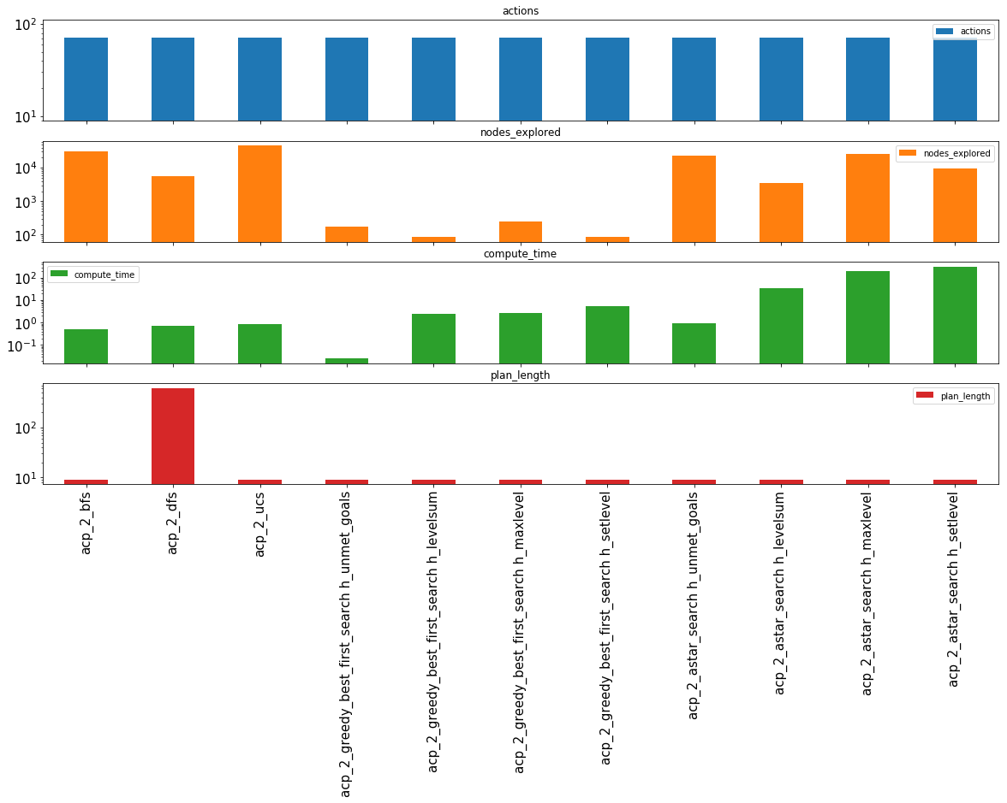

Air Cargo Problem 3:

|  | **actions** | **compute_time** | **graph_expansions** | **nodes_explored** | **plan_length** |
| --- | --- | --- | --- | --- | --- |
| **acp_3_bfs** | 88 | 1.284745 | 14663 | 129625 | 12 |
| **acp_3_dfs** | 88 | 0.316636 | 408 | 3364 | 392 |
| **acp_3_ucs** | 88 | 1.957874 | 18510 | 161936 | 12 |
| **acp_3_greedy_best_first_search h_unmet_goals** | 88 | 0.027968 | 25 | 230 | 15 |
| **acp_3_greedy_best_first_search h_levelsum** | 88 | 4.171586 | 14 | 126 | 14 |
| **acp_3_greedy_best_first_search h_maxlevel** | 88 | 3.591809 | 21 | 195 | 13 |
| **acp_3_greedy_best_first_search h_setlevel** | 88 | 22.038052 | 35 | 345 | 17 |
| **acp_3_astar_search h_unmet_goals** | 88 | 1.705692 | 7388 | 65711 | 12 |
| **acp_3_astar_search h_levelsum** | 88 | 58.063234 | 369 | 3403 | 12 |
| **acp_3_astar_search h_maxlevel** | 88 | 937.574236 | 9580 | 86312 | 12 |
| **acp_3_astar_search h_setlevel** | 88 | 1470.351643 | 3423 | 31596 | 12 |

In [32]:

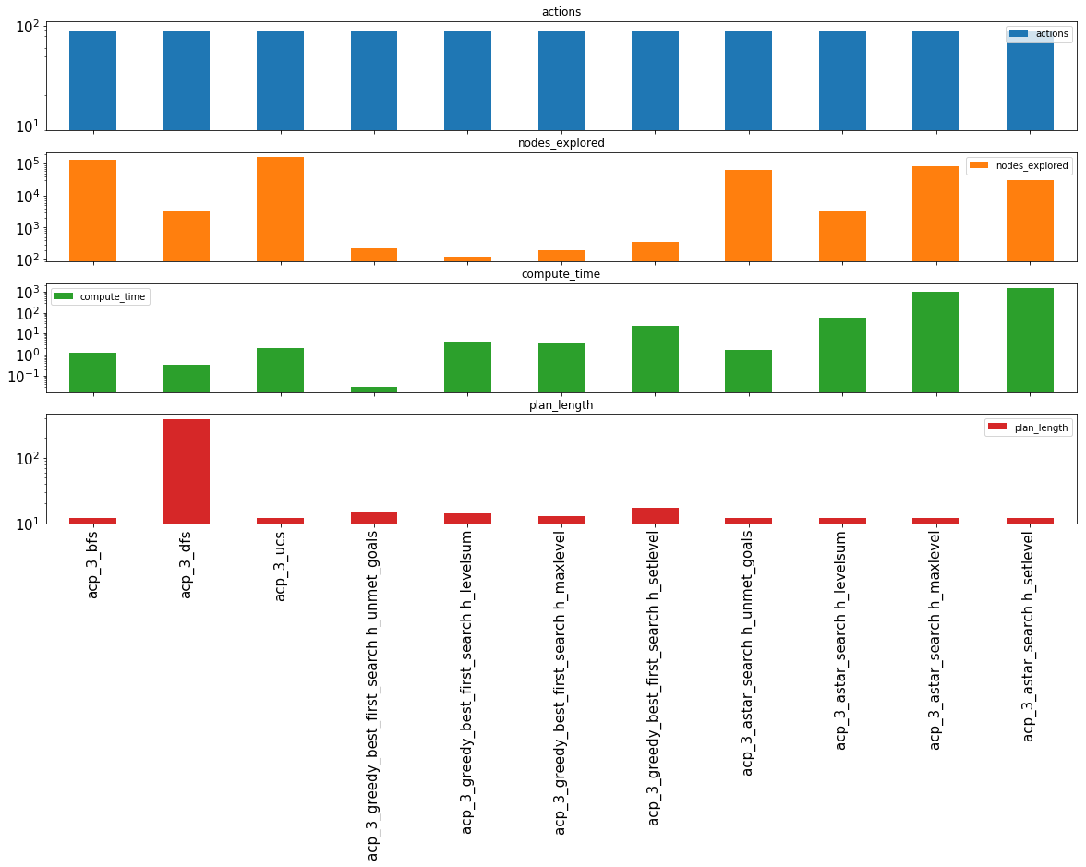

**Questions**[**¶**](http://localhost:8888/notebooks/Classical%20Planning/Classical%20Planning%20Data%20Exploration.ipynb#Questions)

**Which algorithm or algorithms would be most appropriate for planning in a very restricted domain (i.e., one that has only a few actions) and needs to operate in real time?**

**Answer:**

The greedy best first searches algorithms, regardless of heuristics, reliably performed the fast enough for real time operations when action states were kept low.

**Which algorithm or algorithms would be most appropriate for planning in very large domains (e.g., planning delivery routes for all UPS drivers in the U.S. on a given day)**

**Answer:**

Breadth First Search was the more optimal at exploring nodes and expanding the graph. A* searches worked well also at exploring large domains at the trade off for computational expense.

**Which algorithm or algorithms would be most appropriate for planning problems where it is important to find only optimal plans?**

**Answer:**

All A* Search variants and BFS reliably found the most optmial plan.